**To Find the Visualizations – Regents Performance by Subgroup**

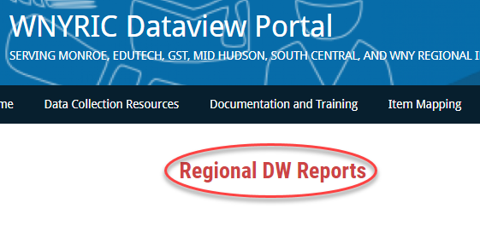

**Go to:** [**https://dataview.wnyric.org**](https://dataview.wnyric.org)

**Choose “Regional DW Reports”**

**Choose the “Team Content” folder**

**Log into Level 1**

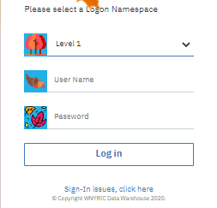 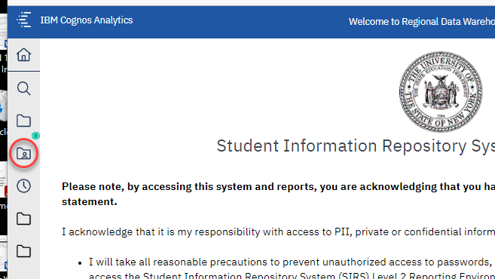

**“Regents Assessment Perfomance Visualization”**

**Choose the “0.3 Visualizations”**

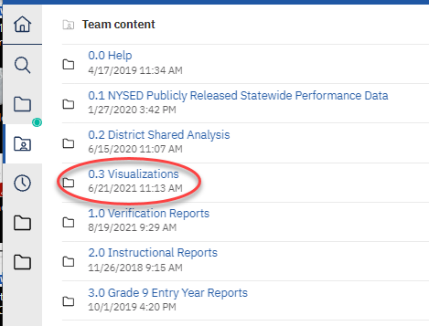 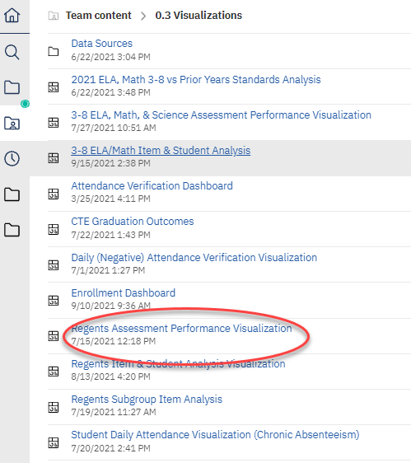

**Go to “District Name,” select your district and click “OK.”**

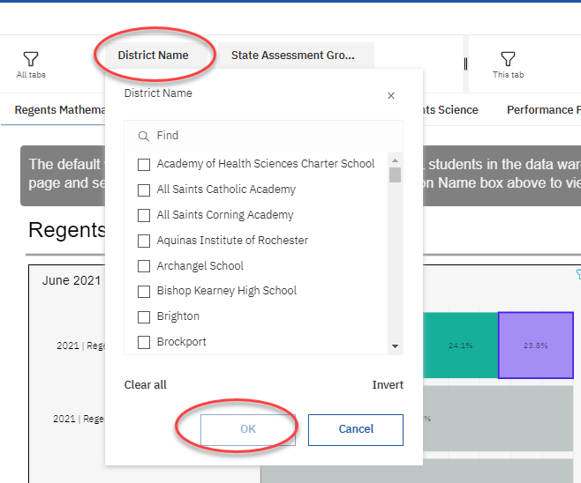 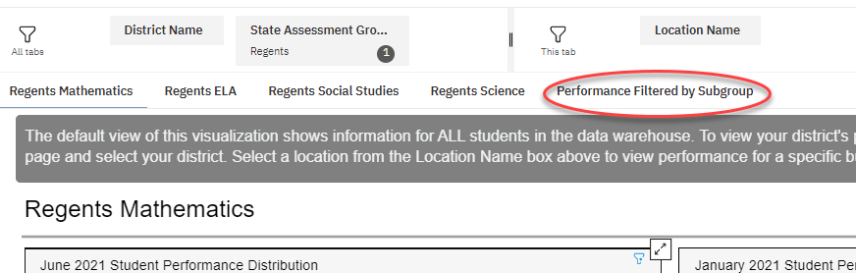

**Select “Performance Filtered by Subgroup”**

**Select the schoolyear(s) and assessment(s) that you want to look at.**

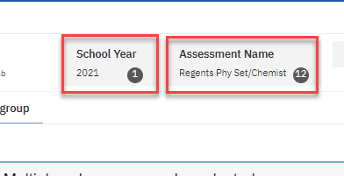

**Remember to de-select anything you do not want to see. For example, de-select 2021 if you only want to see 2019**.

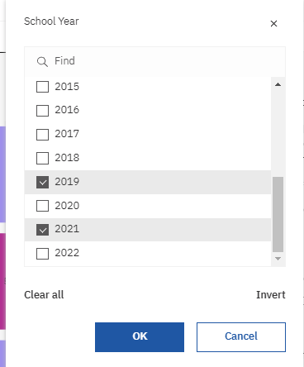 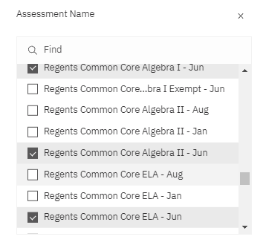

**Select a subgroup. Be sure to de-select a subgroup before choosing another, unless you want multiple groups represented.**

**For example, you could choose students who are female, Hispanic, and ELL eligible**

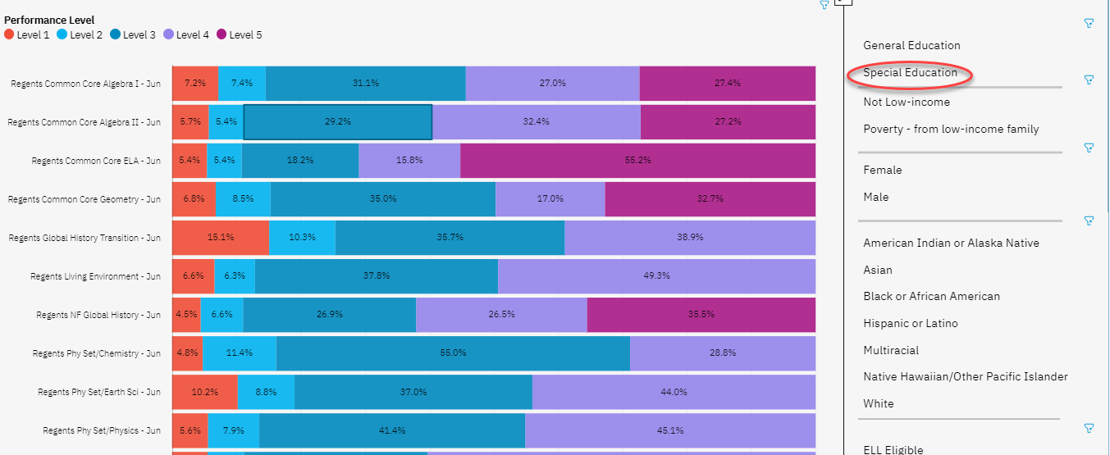

**To see the number of students, hover over the portion of the bar graph.**

